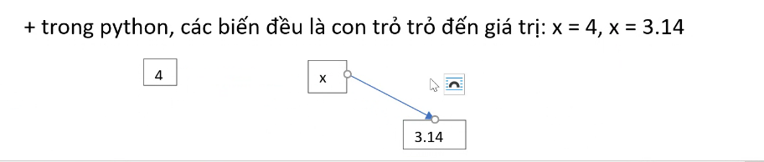

1 biến trỏ đến nhiều giá trị, 1 lần trỏ đc 1 giá trị./

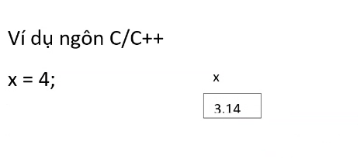

Thay giá trị trong ô. /

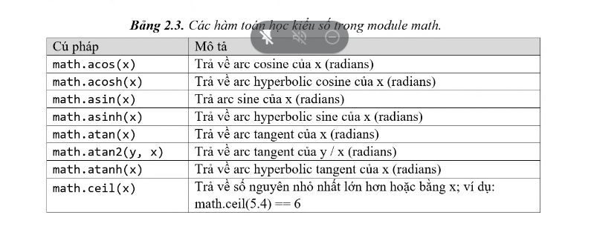

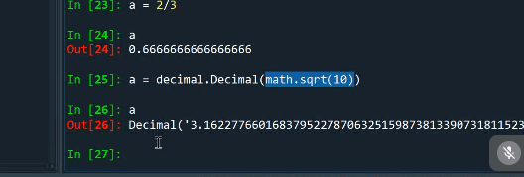



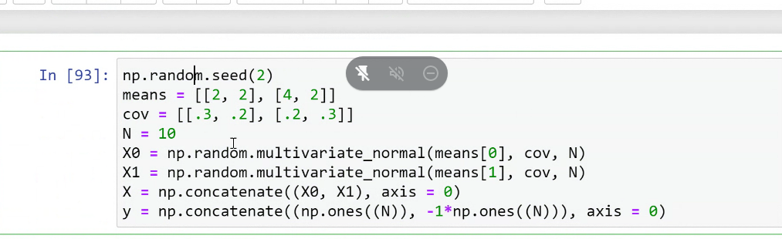

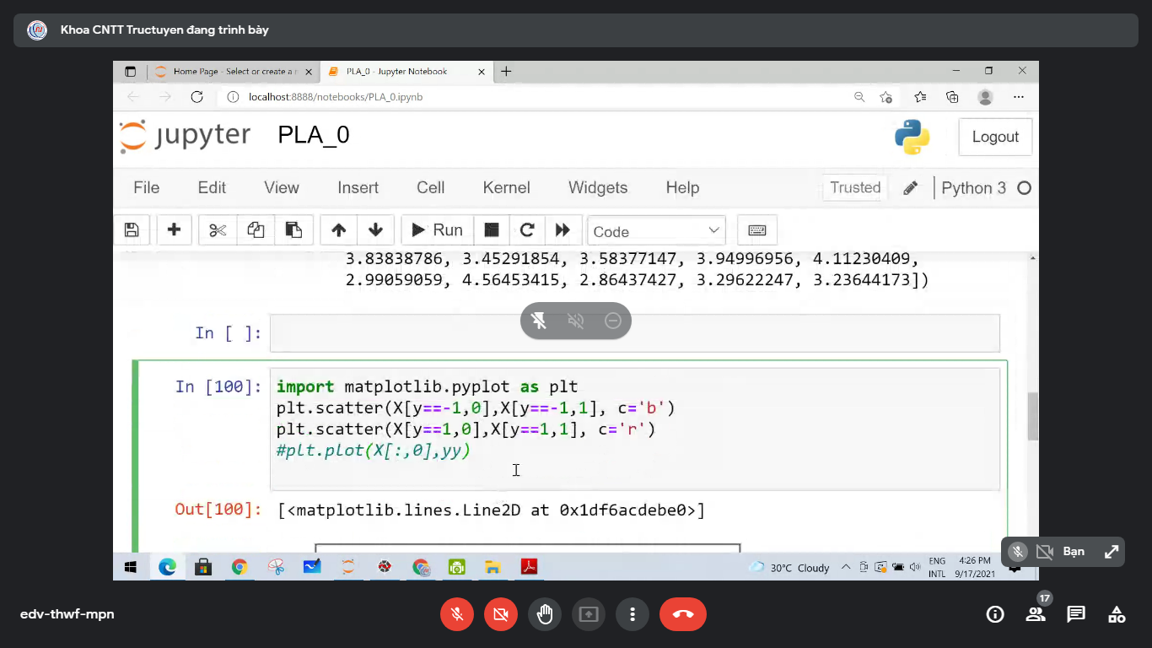

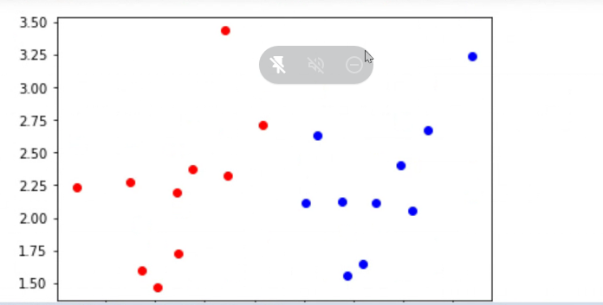

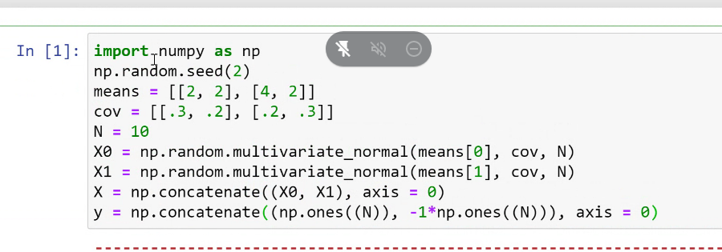

x.shape(20,2) 20gtri va 2 cot

y la cac gia tri -1,1

1, xanh

-1, đỏ

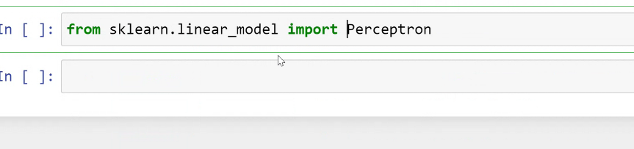

Mo hinh:

Model = perceptron()

Model.fit(X,Y)

perceptron()

print(model.intercept_) 4

print(model.coef_) -5.9, 5.8

w0 = model.intercept_[0] = 4 vi tri thu 0

w1 = model.coef_[0,0] vitri0

w2=model.coef_[0,1]

suy ra pt dt la: y = w1x1 + w2x2 + w0

import matplotlib.pylot as plt

plt.scarter(X[:,0],X[:,1], color = blue)

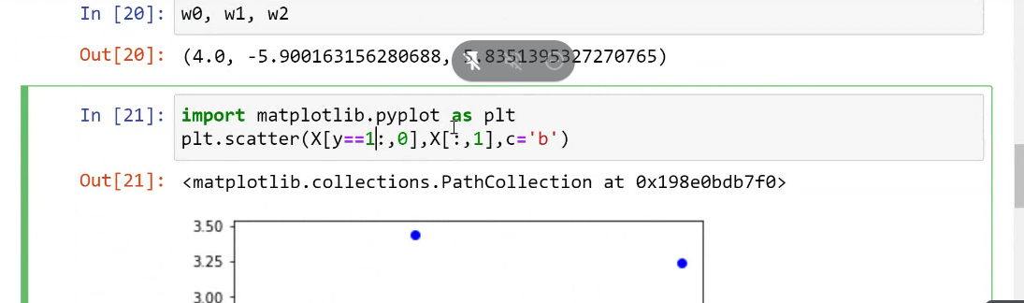

ok

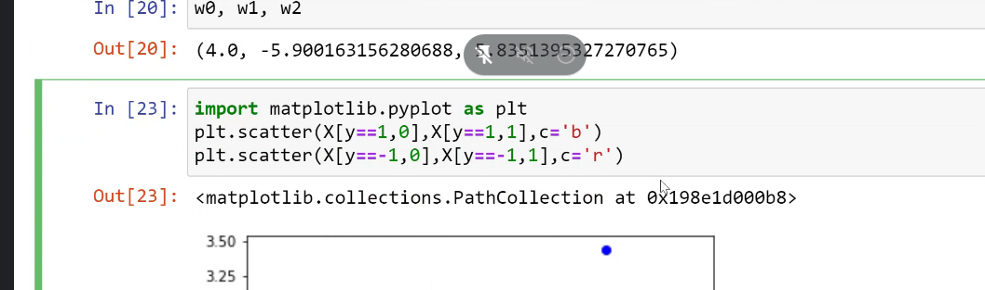

Dt

Yy = -(w0+w1x1)/w2

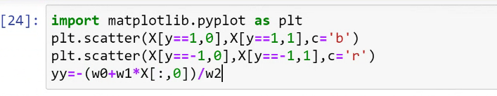

Plt.plot(X[:,0], yy)





